| Date | 22/06/2025 |
| --- | --- |
| Team ID | **LTVIP2025TMID48146** |
| Project Name | iRevolution: A Data-driven Exploration of Apple's iPhone Impact in India using Tableau |
| Maximum Marks | 2 Marks |

**Customer Problem Statement Template:**

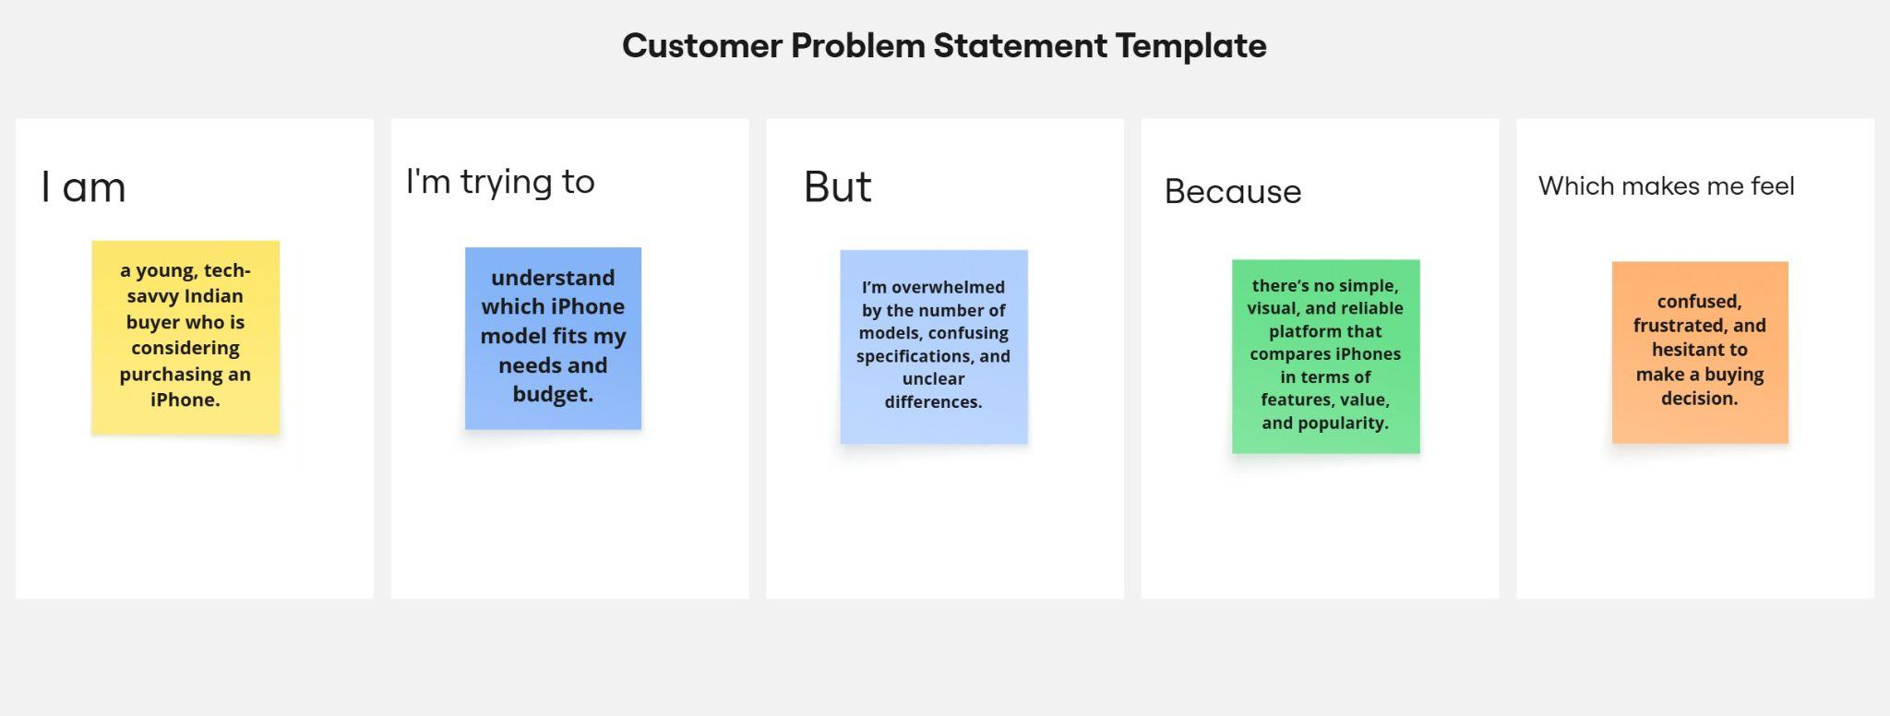

**Different Customer cases – iRevolution:**

Customer 1: Young, tech-savvy Indian buyer

* Trying to find the right iPhone that fits both needs and budget
* Feels overwhelmed by too many models and unclear specifications
* Lacks a simple, visual tool to compare iPhone models
* Feels confused and unsure about making a purchase decision

Customer 2: Data-driven tech consumer

* Wants to compare iPhones with other smartphone brands
* Finds data scattered and hard to interpret
* Sees only raw specs on e-commerce platforms, not useful insights
* Feels uncertain and may delay buying or choose a different brand